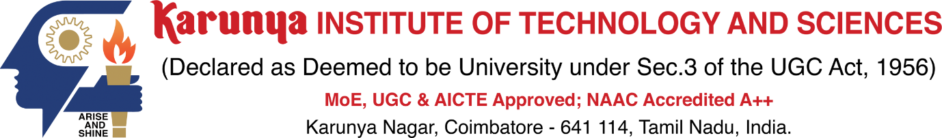

**21EC2016 INTERNET OF THINGS**

**QUALITY ASSESSMENT**

**REALTIME IOT SOFTWARE APP DEVELOPMENT**

**SUBA SHREE**

**URK21EC6039**

**Introduction**

A software application called Student management system is developed with visual studio code software and python programming language. Python is commonly used for developing websites and software, task automation, data analysis, and data visualisation.Visual Studio is an integrated development environment (IDE) from Microsoft. It is used to develop computer programs including websites, web apps, web services and mobile apps. A student management system application is developed to save the list of the students in the class.

**Program:**

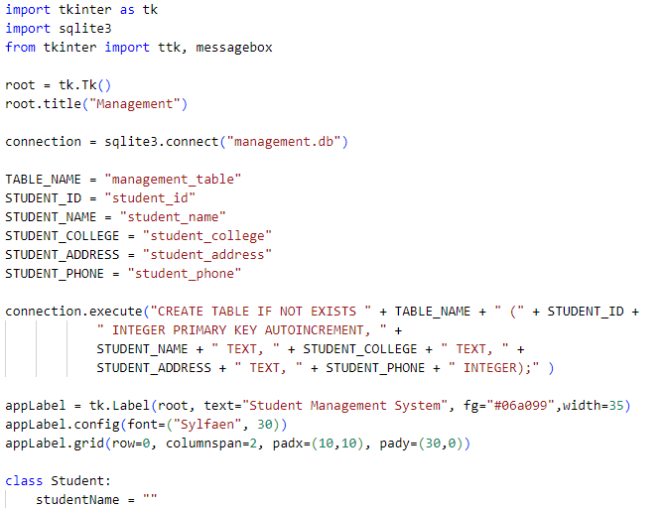

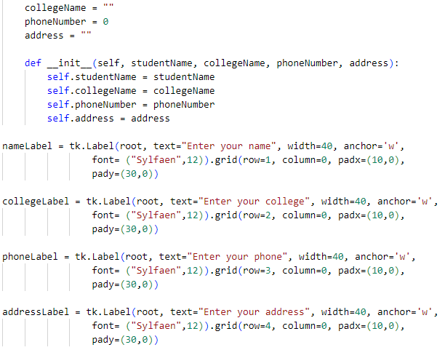

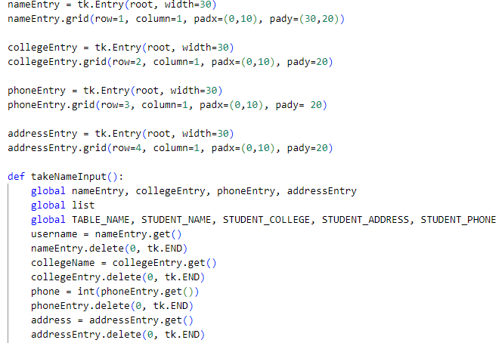

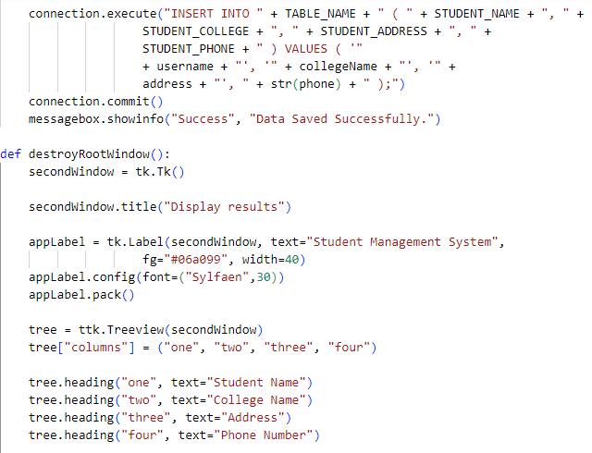

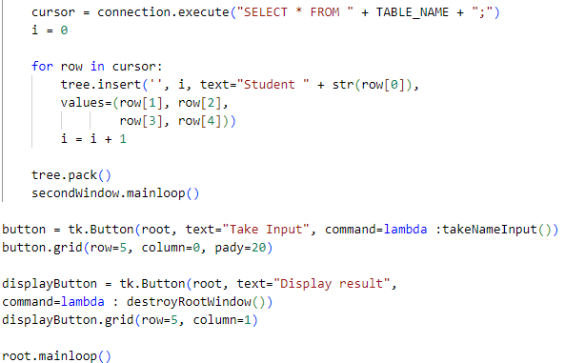

**Output**

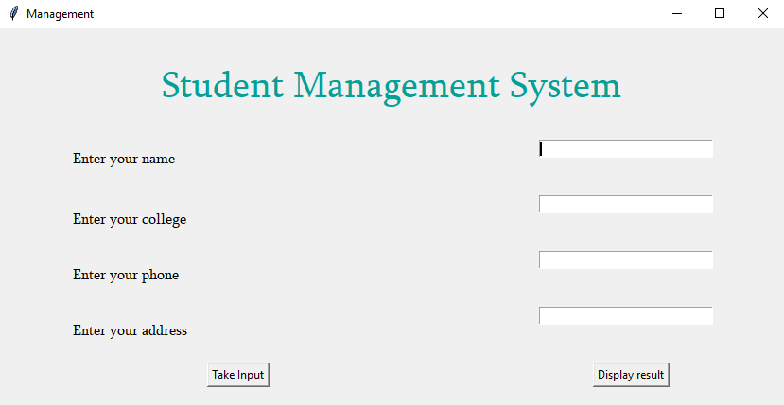

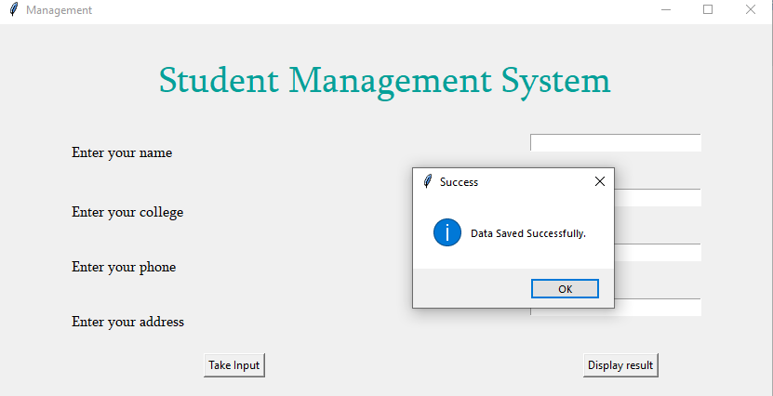

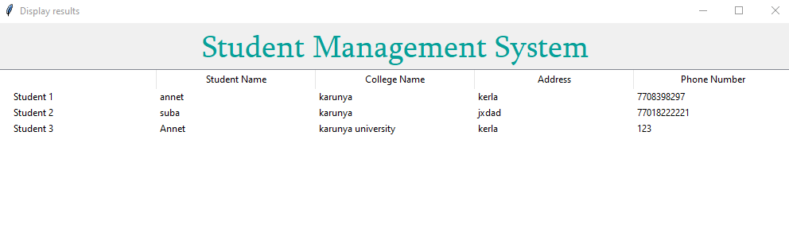**References**

<https://youtu.be/WQlverH1CAI?si=EFaggbCJgs9icksz>